A Report
on
IBOX – A DEKSTOP ASSITANT
carried out as part of the course Project Based Learning- 4
Submitted by
TANAY ANAND
23FE10CSE00476
VI Semester
in partial fulfilment for the award of the degree
of
BACHELOR OF TECHNOLOGY
In
Computer Science & Engineering



Department of Computer Science & Engineering,
School of Computer Science and Engineering,
Manipal University Jaipur,
Jan-May 2026

A Report
On
IBOX- DEKSTOP ASSISTANT
carried out as part of the course Project Based Learning-2/4
Submitted by

TANAY ANAND

23FE1OCSE00476

VI Semester
in partial fulfilment for the award of the degree
of
BACHELOR OF TECHNOLOGY
In
Computer Science & Engineering

Under the Guidance of :

Guide Name : PROF. BALI DEVI

Guide Signature(with date) : ………………………………………

Acknowledgement

This project would not have been completed without the help, support, comments, advice, cooperation and coordination of various people. However, it is impossible to thank everyone individually; I am hereby making a humble effort to thank some of them.

I acknowledge and express my deepest sense of gratitude to my internal supervisor prof.bali devi mam for her constant support, guidance, and continuous engagement. I highly appreciate his technical comments, suggestions, and criticism during the progress of this project titles “ibox-dekstop assistant.”.

I owe my profound gratitude to Dr. Neha Chaudhary , Head, Department of CSE, for her valuable guidance and for facilitating me during my work. I am also very grateful to all the faculty members and staff for their precious support and cooperation during the development of this project.

Finally, I extend my heartfelt appreciation to my classmates for their help and encouragement.

Student Name;- Tanay anand

Registration No. 23FE10CSE00476



Department of Computer Science and Engineering
School of Computer Science and Engineering

Date: 14 april 2026

CERTIFICATE
This is to certify that the project entitled “(ibox-dekstop assistant)" is a bonafide work carried out as PBL-4 End Term Assessment in partial fulfillment for the award of the degree of Bachelor of Technology in Computer Science and Engineering, by (Tanay Anand) bearing registration number (23FE10CSE00476), during the academic semester VI of year 2025-2026.

Place: Manipal University Jaipur, Jaipur

Name of the project guide: PROF. BALI DEVI

Signature of the project guide: ______________________

PROJECT PROGRESS REPORT GUIDELINES

COMPONENTS OF APPLICATION BASED PROJECT REPORT

The sequence in which the project report pages should be arranged and bound should be as follows:

Contents

Table of Contents (with page nos)

- Introduction
  - Objective of the project
  - Brief description of the project
  - Technology used
    - H / W Requirement
    - Software Requirement
  - Organization Profile (if applicable)
- Design Description
  - Flow Chart
  - Data Flow Diagrams(DFDs)
  - Entity Relatoinship Diagram(E-R Diagram)
- Input/Output Form Design
- Testing & Tools used (if applicable)
- Implementation & Maintenance (if applicable)
- Conclusion and Future Work
- Bibliography

Abstract
The I-BOX Desktop Assistant is an intelligent voice-based system developed to facilitate seamless interaction between users and computers through natural language speech. In today’s fast-paced digital environment, traditional methods of interacting with computers using keyboards and mice can be time-consuming and less accessible for certain users. This project aims to overcome these limitations by introducing a smart assistant that responds to voice commands, thereby enhancing user convenience, productivity, and accessibility.
The system integrates advanced technologies such as speech recognition, natural language processing (NLP), and text-to-speech (TTS) to accurately interpret user commands and provide appropriate responses. It is capable of performing a variety of tasks, including searching information on the internet, opening desktop applications, providing real-time data such as date and time, and responding to general user queries. The assistant continuously listens for activation commands and processes spoken input efficiently to deliver quick and accurate outputs.
The implementation of the I-BOX Desktop Assistant is carried out using programming languages like Python along with libraries such as SpeechRecognition, pyttsx3, and other supporting modules. These technologies enable the system to convert speech into text, process the command logic, and generate human-like voice responses. The design of the system emphasizes simplicity, responsiveness, and user-friendliness, making it suitable for both technical and non-technical users.
One of the key objectives of this project is to improve human-computer interaction (HCI) by making it more natural and intuitive. Additionally, the system contributes to accessibility by assisting users who may have physical disabilities or difficulties using traditional input devices. The project also explores the potential of voice assistants in everyday computing tasks and highlights their role in the future of smart systems.
In conclusion, the I-BOX Desktop Assistant demonstrates how voice-enabled technology can significantly enhance user experience by providing a faster, smarter, and more interactive way to operate computers. It serves as a foundation for further development in the field of intelligent personal assistants and automation systems.

1. Introduction
With the rapid advancement of technology, human-computer interaction has shifted toward more natural and intuitive methods. Voice-based systems (also known as voice assistants) aim to enable users to interact with machines using spoken language instead of traditional input methods like keyboards or touchscreens. Despite their growing popularity, several challenges still hinder their efficiency, accuracy, and usability.
Voice assistants are now widely used in smartphones, smart homes, automobiles, and customer service systems, making them an integral part of modern digital life. These systems rely on technologies such as speech recognition, natural language processing, and artificial intelligence to interpret and respond to user commands. The demand for hands-free and faster interaction has further accelerated their adoption across various domains.
However, variations in human speech patterns, including differences in accent, tone, language, and pronunciation, create significant challenges for these systems. Background noise and environmental disturbances also affect the performance of voice recognition systems. Additionally, understanding the context and intent behind user commands remains a complex task.
As a result, there is a growing need to develop more advanced and reliable voice-based systems that can overcome these limitations and provide seamless, accurate, and efficient user interaction.

1.2 Brief Description of the Project
The I-BOX Desktop Assistant is a voice-controlled system designed to enable users to interact with a computer through spoken commands instead of traditional input devices like a keyboard and mouse. The system captures voice input from the user, converts it into text using speech recognition technology, and then processes the command to determine the appropriate action.
The assistant is capable of performing various tasks such as opening websites, launching desktop applications, searching for information online, and controlling basic system functions. It uses text-to-speech technology to provide audio responses, creating a more interactive and user-friendly experience.
The project is developed using Python and integrates different libraries to handle speech recognition, command processing, and voice output. The main aim of this system is to simplify human-computer interaction by making it more natural, efficient, and accessible for users.

1.3 Technology Used
1.3.1 Hardware Requirements
- Microphone
- Computer/Laptop
- Speakers/Headphones
1.3.2 Software Requirements
- Python
- Tkinter (GUI)
- pyttsx3 (Text-to-Speech)
- SpeechRecognition
- Wikipedia module
- Webbrowser
- OS module

2).FLOW CHART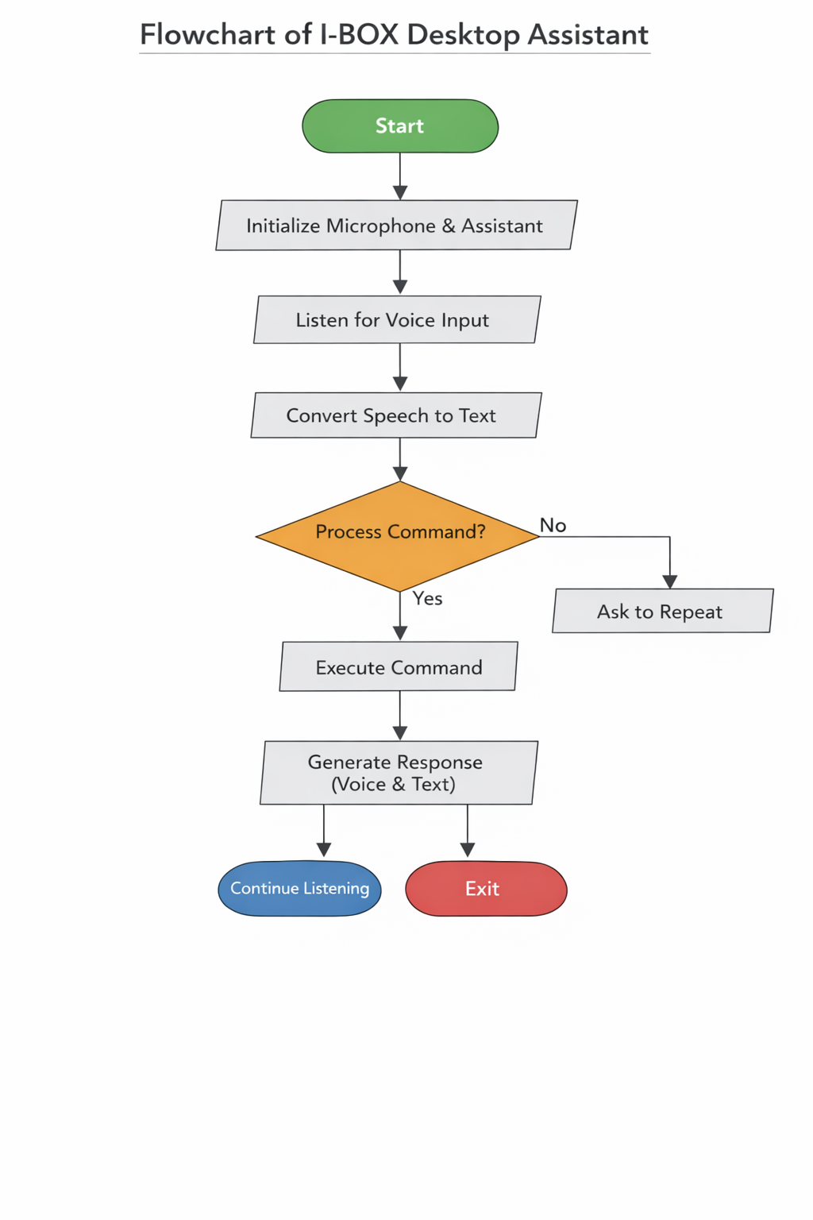
DFD (DATA-FLOW DIAGRAM)
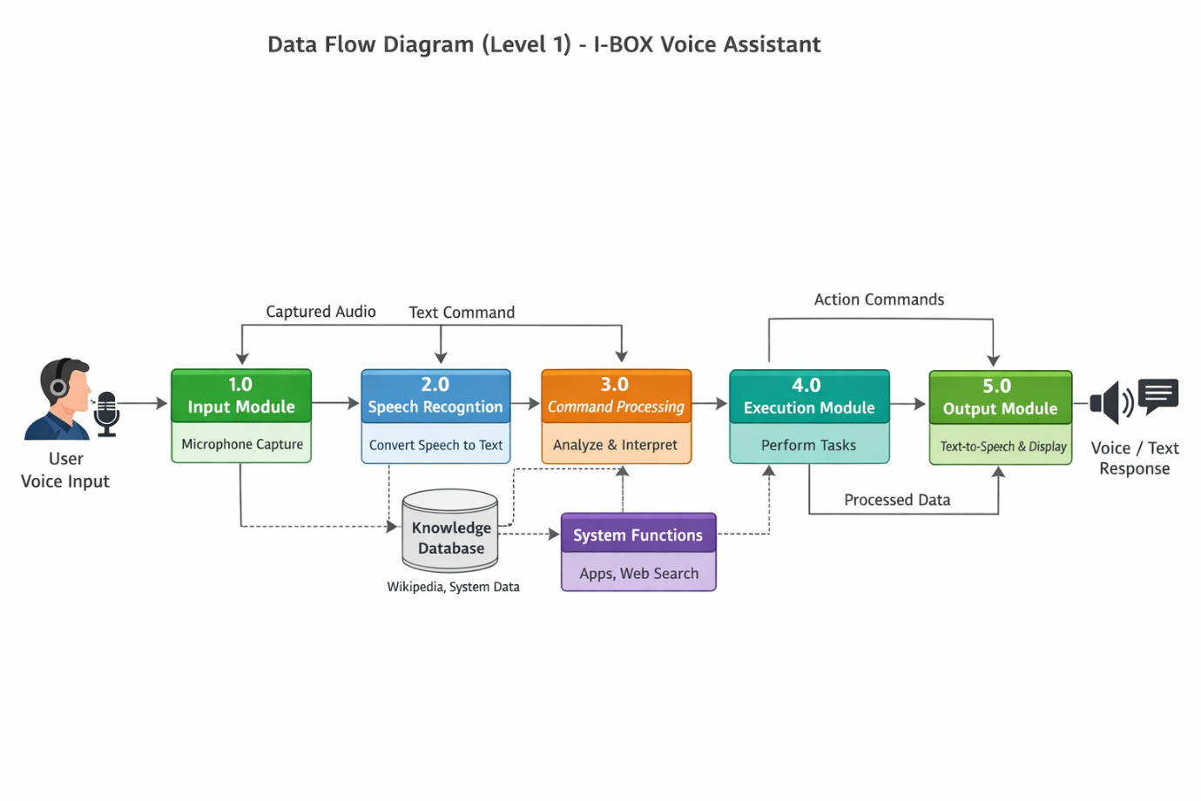

E-R DIAGRAM

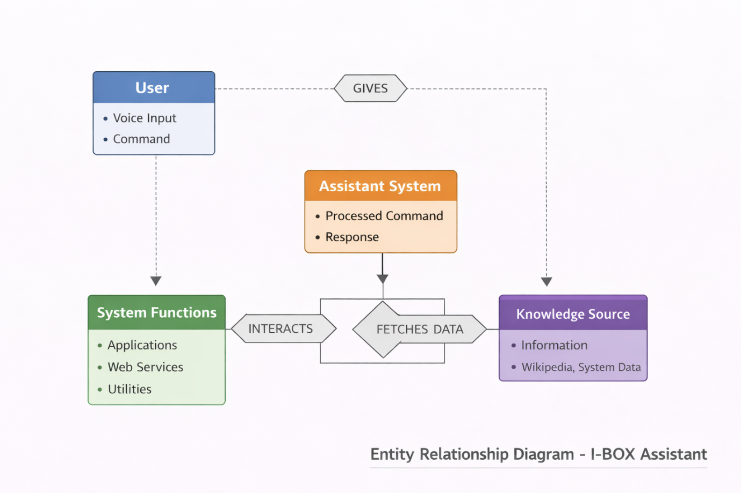
3).INPUT-DESIGN
The primary input to the system is voice input captured through a microphone. The assistant continuously listens for user commands and processes them in real time.
When the user speaks, the microphone captures the audio signal, which is then passed to the speech recognition module. This module converts the spoken words into text format using appropriate libraries and algorithms. The converted text is then analyzed by the system to understand the user’s intent and determine the required action.
The input design ensures:
- Accurate capture of voice commands
- Support for natural language interaction
- Real-time processing of user speech
- Handling of errors such as unclear or unrecognized input
In case the system is unable to recognize the command properly, it prompts the user to repeat the input, thereby improving reliability and interaction quality.

OUTPUT -DESIGN
Output Design
The output of the system is delivered in two main forms: audio response and graphical text display.
- Audio Output (Speech Response):
After processing the command, the system generates a voice response using a text-to-speech (TTS) engine. This allows the assistant to communicate with the user in a natural and human-like manner. The audio output enhances user experience by enabling hands-free interaction and making the system more interactive.
- Graphical User Interface (GUI) Output:
In addition to voice feedback, the system also displays the response in textual form on the screen using a graphical user interface. The GUI includes elements such as text boxes, labels, and buttons that show the recognized command and the corresponding response. This visual feedback helps users verify the system’s understanding and improves usability.
The output design ensures:
- Clear and understandable responses
- Real-time feedback to user commands
- Combination of audio and visual interaction
- Improved accessibility for different types of users

5. Testing & Tools Used
The testing phase is an essential part of the development of the I-BOX Desktop Assistant, as it ensures that the system performs accurately, reliably, and efficiently under different conditions. Various types of testing were conducted to verify the functionality, performance, and usability of the system.

5.1 Testing
1. Functional Testing
Functional testing was carried out to verify whether all the features of the assistant are working as expected. Each command given by the user was tested to ensure proper execution.
Examples include:
- Opening websites (Google, YouTube, etc.)
- Launching applications
- Fetching information (e.g., Wikipedia search)
- Providing date and time
This testing ensured that the system correctly interprets commands and performs the intended action without errors.

2. Accuracy Testing (Speech Recognition)
Accuracy testing focused on evaluating how well the system recognizes and converts spoken language into text.
The assistant was tested under different conditions such as:
- Different accents and pronunciations
- Variations in speech speed
- Background noise environments
The results helped in identifying limitations and improving recognition accuracy. Error handling mechanisms were also tested to manage cases where the input was not properly understood.
3. GUI Testing
GUI (Graphical User Interface) testing was performed to ensure that the interface is user-friendly, responsive, and visually clear.
Key aspects tested:
- Proper functioning of buttons (Start, Stop, etc.)
- Display of recognized text and responses
- Layout and alignment of components
- Responsiveness of the interface
This ensured that users can interact with the assistant easily without confusion or errors.
4. Performance Testing
Performance testing was conducted to evaluate the speed and responsiveness of the system.
Focus areas:
- Time taken to process voice commands
- Delay in generating responses
- Smooth functioning during continuous use
This testing ensured that the assistant provides real-time interaction with minimal lag.
5. Integration Testing
Integration testing was done to verify that all modules (speech recognition, processing, execution, and output) work together seamlessly.
It ensured:
- Proper data flow between modules
- No conflicts between components
- Smooth execution of complete workflow
5.2 Tools Used
1. Python IDE (VS Code / PyCharm)
Python Integrated Development Environments (IDEs) such as VS Code and PyCharm were used for writing, editing, and debugging the code.
Features:
- Syntax highlighting
- Debugging tools
- Code suggestions and auto-completion
- Easy project management
These tools helped in efficient development and error detec
2. Tkinter
Tkinter is a standard Python library used for developing the graphical user interface (GUI) of the assistant.
Functions:
- Creating windows and layouts
- Adding buttons, labels, and text boxes
- Handling user interactions
It enabled the creation of a simple, interactive, and user-friendly interface.
3. SpeechRecognition
The SpeechRecognition library was used to convert voice input into text.
Key features:
- Supports multiple speech recognition engines
- Captures audio from microphone
- Converts speech into machine-readable text
This tool is the core component responsible for enabling voice interaction.
4. pyttsx3 (Text-to-Speech Engine)
This library was used to convert text responses into speech output.
Advantages:
- Works offline
- Provides voice customization
- Fast and reliable
It allows the assistant to communicate responses in a natural voice.
6. Implementation & Maintenance
The implementation phase involves the actual development and deployment of the I-BOX Desktop Assistant, where all the planned features and system design are converted into a working application. Maintenance ensures that the system continues to function efficiently over time and adapts to new requirements and improvements.
6.1 Implementation
The I-BOX Desktop Assistant was implemented using the Python programming language, which provides flexibility and a wide range of libraries for building voice-based applications.
The implementation process includes the following key aspects:
1. Development Using Python
The entire system logic, including speech processing, command handling, and system operations, was coded in Python. Python was chosen due to its simplicity, readability, and strong support for AI and automation-related libraries.
2. Integration of Speech Recognition
Speech recognition functionality was integrated using libraries such as SpeechRecognition. This allows the system to:
- Capture voice input through a microphone
- Convert speech into text
- Process commands in real time
This module acts as the primary interface between the user and the system.
3. Text-to-Speech Integration
The system uses a text-to-speech engine (pyttsx3) to convert textual responses into spoken output. This enables:
- Interactive communication
- Hands-free operation
- Natural and user-friendly responses
4. Graphical User Interface (GUI) Development
A simple and interactive GUI was developed using Tkinter. The interface includes:
- Buttons (Start, Stop, Exit)
- Display area for commands and responses
- Basic layout for user interaction
This makes the assistant accessible even to non-technical users.
5. Command Processing and Execution
The system processes user commands using conditional logic and predefined functions. Based on the recognized command, the assistant:
- Opens applications
- Searches the web
- Provides system information
- Executes specific tasks
6. Testing on Desktop Environment
The assistant was tested on a desktop environment to ensure:
- Proper microphone functionality
- Smooth GUI performance
- Accurate command execution
Testing helped in identifying bugs and improving system stability
6.2 Maintenance
Maintenance is an ongoing process that ensures the system remains efficient, accurate, and up-to-date after deployment.
1. Regular Updates for Accuracy
Speech recognition models and command handling logic are periodically updated to improve accuracy. This includes:
- Handling different accents and pronunciations
- Reducing recognition errors
- Improving response quality

2. Adding New Commands and Features
To enhance functionality, new commands and features can be added over time, such as:
- Controlling more applications
- Adding reminders or task scheduling
- Integration with external APIs or services
This makes the assistant more powerful and versatile.

3. Performance Improvement
Continuous optimization is performed to:
- Reduce response time
- Improve processing speed
- Ensure smooth multitasking
This enhances overall user experience.

4. Bug Fixing and Error Handling
Any issues identified during usage are fixed through updates. Error handling mechanisms are improved to:
- Manage unrecognized commands
- Prevent system crashes
- Provide user-friendly error messages

7).Conclusion
The development of a robust voice-based assistant system requires addressing multiple technical challenges related to speech recognition, natural language processing, and system responsiveness. Ensuring high accuracy in understanding user input, even in noisy environments or with diverse speech patterns, remains a critical aspect of building an effective system.
In addition to technical accuracy, the system must also focus on providing meaningful and context-aware responses. The ability to interpret user intent correctly and respond in a conversational and human-like manner plays a key role in enhancing user satisfaction and trust. Performance optimization, including reducing delays and improving real-time interaction, is equally important for delivering a smooth user experience.
Furthermore, the integration of such systems across various platforms and applications highlights their growing importance in modern technology. From personal assistance to smart home automation and professional productivity, voice-based assistants have the potential to transform the way users interact with digital systems.
A well-designed solution can significantly improve accessibility, especially for individuals with physical limitations, and promote hands-free, efficient interaction.
In conclusion, developing an intelligent, reliable, and scalable voice-based assistant system not only enhances user experience but also paves the way for smarter, more intuitive, and future-ready digital environments.

9. Bibliography
(You can copy this directly)
- Python Documentation – https://docs.python.org
- SpeechRecognition Library Documentation
- pyttsx3 Documentation
- Wikipedia API Documentation
- Online tutorials and research papers on Voice Assistants

